Radioactivity and Nuclear Chemistry
Atomic theory in the nineteenth century presumed that nuclei had fixed compositions. But in 1896, the French scientist Henri Becquerel found that a uranium compound placed near a photographic plate made an image on the plate, even if the compound was wrapped in black cloth. He reasoned that the uranium compound was emitting some kind of radiation that passed through the cloth to expose the photographic plate. Further investigations showed that the radiation was a combination of particles and electromagnetic rays, with its ultimate source being the atomic nucleus. These emanations were ultimately called, collectively, radioactivity
Radioactivity is thus the emission of particles and radiation from nuclear reactions. These nuclear reactions include radioactive decay by unstable atomic nuclei, fission, and fusion.
The spontaneous change of an unstable nuclide into another is radioactive decay. The unstable nuclide is called the parent nuclide; the nuclide that results from the decay is known as the daughter nuclide. The daughter nuclide may be stable, or it may decay itself.

Major Forms of Radioactivity

Alpha Particle (α)
Rutherford’s experiments demonstrated that there are three main forms of radioactive emissions. The first is called an alpha particle, an alpha particle is composed of two protons and two neutrons and is the same as a helium nucleus. (We often use ₂⁴He to represent an alpha particle.) It has a 2+ charge. When a radioactive atom emits an alpha particle, the original atom’s atomic number decreases by two (because of the loss of two protons), and its mass number decreases by four (because of the loss of four nuclear particles). We can represent the emission of an alpha particle with a nuclear equation—for example, the alpha-particle emission of uranium-235 is as follows:
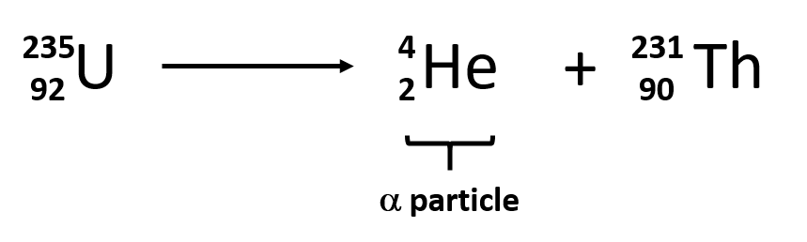

Beta Particle (β)
The second type of radioactive emission is called a beta particle, a beta particle is an electron ejected from the nucleus (not from the shells of electrons about the nucleus) and has a -1 charge. We can also represent a beta particle as ₋₁⁰e. The net effect of beta particle emission on a nucleus is that a neutron is converted to a proton. The overall mass number stays the same, but because the number of protons increases by one, the atomic number goes up by one. Carbon-14 decays by emitting a beta particle:
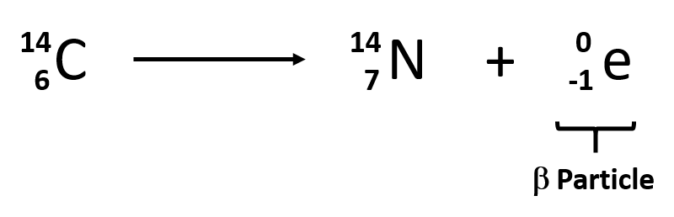

Gamma Radiation (γ)
The third major type of radioactive emission is not a particle but rather a very energetic form of electromagnetic radiation called gamma rays. Electromagnetic radiation can be characterized into different categories based on the wavelength and photon energies.
Some electromagnetic radiation with very short wavelengths are active enough that they may knock out electrons out of atoms in a sample of matter and make it electrically charged. The types of radiation that can do this are termed ionizing radiation. X-rays and Gamma rays are examples of ionizing radiation. Some radioactive materials, emit gamma radiation during their decay. For example, in the decay of radioactive technetium-99, a gamma ray is emitted. Note that in radioactive decay where the emission of gamma radiation occurs, that the identity of the parent material does not change, as no particles are physically emitted.
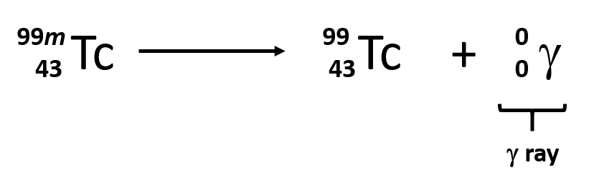
Sometimes the radioactive decay of a sample can result in the release of multiple forms of radioactivity. For example, in the radioactive decay of radon-222, both alpha and gamma radiation are emitted, with the latter having an energy of 8.2 × 10⁻¹⁴ J per nucleus decayed:
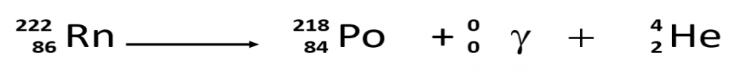
This may not seem like much energy, but if 1 mol of Rn atoms were to decay, the gamma ray energy would be 4.9 × 10⁷ kJ!
Alpha, beta, and gamma emissions have different abilities to penetrate matter. The relatively large alpha particle is easily stopped by matter (although it may impart a significant amount of energy to the matter it contacts). Beta particles penetrate slightly into matter, perhaps a few centimeters at most. Gamma rays can penetrate deeply into matter and can impart a large amount of energy into the surrounding matter. The table below summarizes the properties of the three main types of radioactive emissions
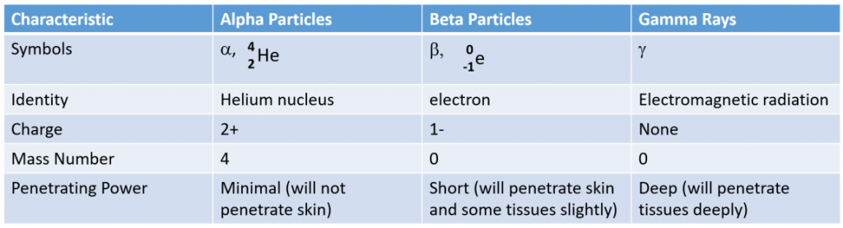
Radioactive Half Lives
Each radioactive nuclide has a characteristic, constant half-life (t_{1/2}), the time required for half of the atoms in a sample to decay. An isotope’s half-life allows us to determine how long a sample of a useful isotope will be available, and how long a sample of an undesirable or dangerous isotope must be stored before it decays to a low-enough radiation level that is no longer a problem.
For example, cobalt-60, an isotope that emits gamma rays used to treat cancer, has a half-life of 5.27 years. In a given cobalt-60 source, since half of the nuclei decay every 5.27 years, both the amount of material and the intensity of the radiation emitted is cut in half every 5.27 years. Note that for a given substance, the intensity of radiation that it produces is directly proportional to the rate of decay of the substance and the amount of the substance. Thus, a cobalt-60 source that is used for cancer treatment must be replaced regularly to continue to be effective.
Since every half-life for a radionuclide is the same length of time, we can use the following equation to calculate how much radioactive nuclide is remaining after the passage of any number (n) of half-lives:

Question: The half-life of Zn-71 is 2.4 minutes. If one had 100.0 g at the beginning, how many grams would be left after 7.2 minutes has elapsed?
Solution:
Step 1. Determine the number of half-lives that have passed: number of half-lives = time passed divided by the half-life (Be sure that the time units match!!)

Step 2. Use the Isotope Remaining equation to solve for how much isotope will remain after the number of half-lives determined in step 1 have passed.
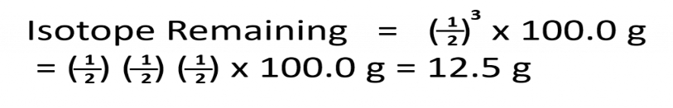

Uses of Radioactive Isotopes
Radioactive emissions can cause damage to biological systems by causing the breakdown of proteins and DNA. This can lead to cellular and genetic damage and increase a person’s risk for diseases like cancer. However, when used is small quantities and in controlled settings, radioactive tracers and treatments have proven to be revolutionary for the medical field. For example, Radiation therapy is the use of high-energy radiation to damage the DNA of cancer cells, which kills them or keeps them from dividing. Radioactive tracers have also been very useful in evaluating heart disease, thyroid dysfunction, and other blood disorders. Positron emission tomography (PET) scans use radiation to diagnose and track health conditions and monitor medical treatments by revealing how parts of a patient’s body function and X-rays have long been used to visualize breaks in bones and cavities in teeth.

